Physical Barriers in Video Games

By Barrie Ellis (OneSwitch.org.uk) - 20th March 2006 (partial update 5th December 2006)

Index

- Physical Barriers Gamers Regularly Face and Why
- Accessible Game Controllers
- Accessible Games
- One Switch Games
- Strange Attractors One Switch Game
- Accessibility Tips for All Games
- Conclusion

1. Physical Barriers Gamers Regularly Face and Why

Inaccessible controllers and inaccessible games are the bane of many disabled peoples lives.

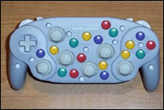
Many games have too many buttons to remember, are too fast, and have very little help to offer the player at all.

Many games won’t allow people to use their favourite controllers, nor change the layout of their controls in a useful way.

These barriers cause frustration for many. Games a person might desperately want to play, frequently prove to be an unrewarding, uncomfortable, or impossible challenge in reality.

Disabled people regularly facing these barriers are novice gamers, physically disabled gamers, learning disabled gamers and many children up to the age of eight.

1971: The Bronze Age of Inaccessible Video Games

It is worth noting that the first video game adopted by the mainstream public was Atari’s Pong in 1972 with just one simple paddle controller needed to play. It was not Nutting Associate’s earlier video game Computer Space, which failed in large part, due to it’s complicated controls and nature^{1.1}.

Into The Modern Era

Video Games such as Taito’s Space Invaders in 1978 and Namco’s Pac-Man in 1980 carried on this success, aided by simple controls and immediately understandable game play. However, from Williams’ Defender^{1.2} on, games of increasing complexity, rapidly began to exclude elements of the gaming public.

With the arrival of the Sony Playstation in 1994, and its 14 button game controller, gaming had rarely seemed more complicated. In 1997 Sony’s replacement Dual-Shock controller, with its two analogue sticks and 16 effective buttons, seems to have marked the summit of standard controller complexity.

If you know a gamer with arthritis, or small hands, or someone who has never played a game before, or has learning disabilities, or someone with paralysis, such controllers can make gaming a mountainous task. However, with an alternative controller, and some simple software features, many of these barriers can be removed for the benefit of all gamers. This presentation hopes to shed some light on ways forward…

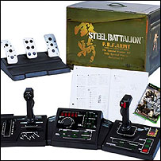

Steel Battalion © Capcom

An extreme example of, what is to many, a completely inaccessible game and controller

2. Accessible Game Controllers

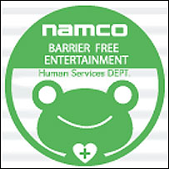
Gamers finding JoyPad styled controllers inaccessible have to track down a better alternative, or give up. Many people try to make do with the best standard controller they can find that is compatible. Considering the vast range of devices in existence, especially for the Playstation One and Playstation 2 consoles, many people find a good fit. Many others do not…

Some people find that they need to make use of adapted controllers, where more accessible controls can be added. This is achieved with the help of family members, charities such as MERU and REMAP, and businesses such as OneSwitch, RJ Cooper, Kokoto Step, and Namco’s Human Services Department in Japan.

Finally, some people purchase specialised accessible controllers, manufactured by the likes of Enabling Devices and Crick Software. A good starting point to track any of these controllers and organisations is at OneSwitch.org.uk.

Accessible Switch Standard

One standard that physically and learning disabled gamers can take advantage of, is the accessible switch standard. There are a huge range of off-the-shelf switches and sensors that can connect to adapted equipment via a 3.5mm mini-headphones style socket. The beauty of these individual controls is that they can be positioned by the parts of the body most able to operate them. They can also be shared out to play in teams, which can work wonderfully. Imagine two children, one severely disabled and one able bodied playing a driving game together. One child could take care of navigating menus and perhaps steering, and the other could take care of the ‘pedals’ for stop and go. All that is needed is a games machine, switch interface and switches.

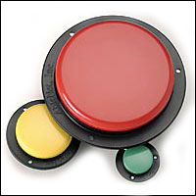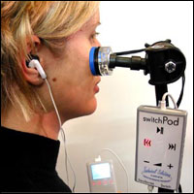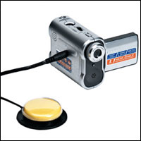

A small sample of the huge range of accessibility switches and switch adapted equipment available.

Problems gamers frequently face
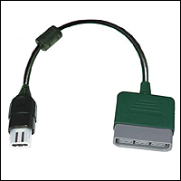
Finding an accessible controller in the first place.

This will always require some trial and error, but tracking accessibility solutions is becoming easier thanks to the internet and growing awareness.

Compatibility issues.

A massive problem for disabled gamers for several reasons. Many recent games lock out non-analogue and non-standard controllers. This makes play impossible for people relying upon these. This is increasingly even the case with digital arcade sticks that have emulated analogue modes.

The lack of compatibility between manufacturers consoles is also a great frustration, but can be overcome in some instances with Playstation controller adapters. The lack of compatibility between manufacturers own consoles is also a generational annoyance, excluding the superb degree of compatibility between Sony’s PS One and PS2 consoles.

Standard controllers

It’s likely that the majority of physically disabled gamers in the world are using standard controllers, in a style they find useable. The following are just some of these controllers in use today by ‘enabled gamers’.

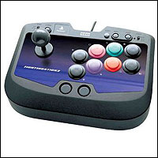

Arcade Sticks

The larger controls of an Arcade Stick can offer a solution to those finding JoyPads awkward to use. The downside is that many games now require the use of two analogue sticks simultaneously. Many games lock out arcade sticks, even those with analogue emulation, rendering them useless.

Fighting Stick 2 pictured © HORI

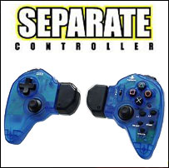
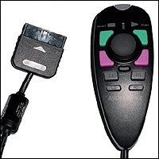

One Hand Controllers

Originally designed with Role Playing Gamers in mind, enabling them to play and make notes at the same time. These controllers can be of enormous benefit to gamers unable to use both hands.

Limits can come where the sheer number of controls within a game makes play uncomfortable or impossible.

ASCII Grip V2 © ASCII and SEPARATE Controller © HORI pictured
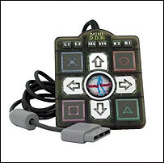

MINI Dance Mat Controllers

Enable some gamers to compete against able-bodied people at Dance Mat games. Other compatible games can be played with this controller too.

Limitations come with analogue only games, which will often lock this game controller out.

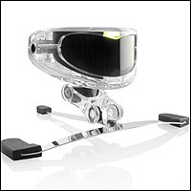

Head Trackers

Gamers can control certain PC games using the motion of their head. These head positions can also be mapped to act as specific keys on a keyboard with some head trackers.

Unfortunately, as software drivers are required, some commercial games shut this device out. Finding playable games can be a very hit and miss affair.

TRACKIR pictured © Natural Point

Adapted controllers

Another way for disabled gamers to gain access to games machines is in fairly simple adaptations to existing controllers. These are carried out by individuals, charities and a small number of businesses. Typical adaptations include:

- Adding sockets for external switches. Controls can then be positioned at different parts of the body or even shared out for team play.
- Extending joysticks. Many are simply too small, and difficult to use.
- Making buttons easier to press. Many standard buttons are small, and too closely positioned for many.
- Adding Sip/Puff switches for mouth control.
- Brackets to hold controllers in place. If you can’t reach your controls, they are not a lot of use!

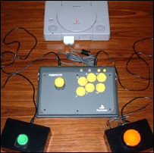
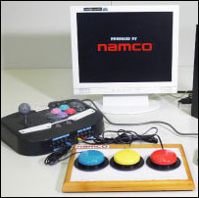

Adapted Namco Arcade Stick Adapted HORI Fighting Stick
by OneSwitch.org.uk (UK) by NAMCO Barrier Free Department (Japan)

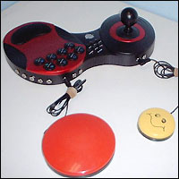
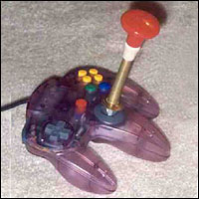
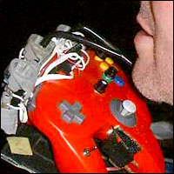

Adapted Wireless Pelican Stick Adapted Nintendo 64 controller Adapted N64 controller for Sip/Puff use
By RJ Cooper (USA) by PDG (USA) by Mark Bosanquet-Bryant (UK)

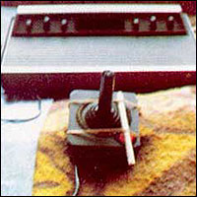
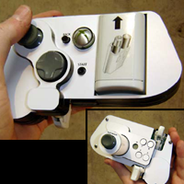

Adapted Atari 2600 Joystick One Hand adapted Xbox 360 controller

by John Dutton (UK) c.1982 by Ben Heck (USA)

Purpose Built accessible controllers

These are controllers from scratch with disabled gamers in mind. The following details some of these controllers, but is not comprehensive.

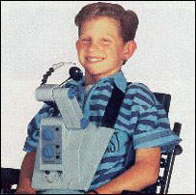
Nintendo Hands Free controller for the NES

Nintendo became the first major games company to release a controller aimed squarely at disabled gamers in 1988, with their Hands Free^{2.1} controller for the NES. These devices were designed for Quadriplegic gamers, and sold in very small numbers to US and European markets.

The D-pad functions are operated by moving your chin on an extended joystick. The A and B buttons are controlled via a mouth controlled SIP/PUFF controller.

Limits of this device seem to be in the lack of an accessible START button. Many NES games can not be started without this, so the user would likely have to rely upon a helper. This is a common problem for switch gamers to this day.

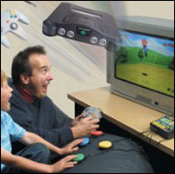
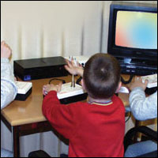

Switch Interfaces

Allowing accessibility standard switches to connect to games machines. Popular with PC and Mac gamers, these have also been officially released for the Super Nintendo, N64, Game Boy Advance and Playstation 2.

These allow a wide range of external plug in controls to operate the controls of a game.

Team Xtreme N64 Playstation 2 Switch Interface
Pathways Development Group ROMPA
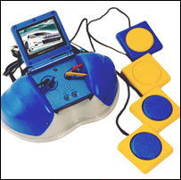
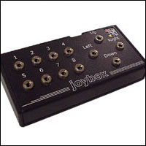

The main limitation for switch interfaces is in their digital nature. Plug in buttons are generally either on or off in state, with no graduation in between. Games reliant upon analogue controls can prove difficult or impossible to switch gamers.

There are also problems with games that do not allow you to redefine every control, leaving some interfaces incompatible.

Game Boy Adapter JoyBox USB Switch Interface
Enabling Devices Sensory Software

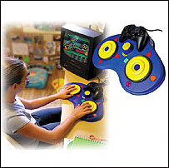

Simplified Controllers

Enabling Devices recently released their Playstation Control Centre aimed at physically and learning disabled gamers. The directional pad and shape controls can all be accessed by two yellow disks that you can rock your hand over to activate.

Limitations are in games requiring analogue controls other than the D-Pad and shape buttons.

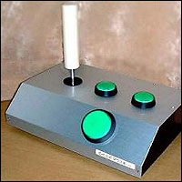
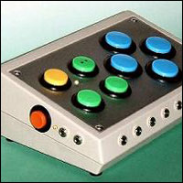

Kokoto Step Controllers

This Japanese organisation tailor makes accessible PC controllers using a range of standard parts.

Limitations are in games requiring analogue controls.

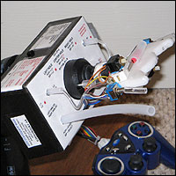

QuadController

The Quad Controller is designed for people who use only their heads to play games due to paralysis. This controller is operated using a combination of lip switches, sip/puff switches, and a joystick operated by moving the head.

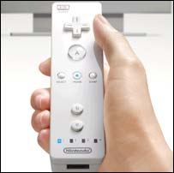

The Near and Distant Future of Accessible Controls

In the near future, many eyes are on Nintendo’s one handed Wii remote controller. This should be of fantastic benefit to gamers struggling with traditional JoyPads.

However it shall remain to be seen if the range of movement needed to play will exclude many disabled gamers or not.

One great hope is for a wireless standard to be agreed upon between console manufacturers. Why shouldn’t you be able to take your favourite controller and use it on any games machine? Especially when your controller costs as much or more than your games console.

Nintendo Revolution Controller
© Nintendo
3. Accessible Games

It is not only the physical controls that can cause barriers for gamers, but of course the design of games themselves. Many games in the past have featured accessibility features, but seldom have they been put in place with any deliberate consideration for disabled gamers. This seems to be especially the case with console games. None the less, what was put in place to benefit the novice gamer, can often benefit a huge range of people.

Everybody’s Golf 2 (Clap Hanz - 2000)

This Playstation game, also known as Hot Shots Golf 2, features some simple accessibility elements that would benefit ALL golf games.

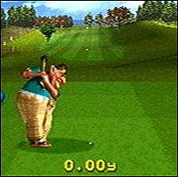
A novice level that removes hook and slice

Many golf games require an extremely high level of timing in order to hit a shot in a straight line. This puts many golf games out of the reach of gamers who don’t have this degree of skill. To be able to remove the annoyance of a ball continually veering wildly off to the left or right can be the difference between a fun game and an abandoned game.

A handicap system

The golfing handicap system, allows golfers of any range of ability to compete equally on the same course. This is achieved by adjusting each players score at the start of a game. The better you are, the smaller the shot advantage you will play with.

Free practice on all courses, including a driving range and putting green

A simple free practice mode gives a player the chance to play against their self. This is especially useful for gamers finding the actual game too hard, by giving them an area to practice, without pressure.

Simple controls, with digital only compatibility

As mentioned before, analogue controls can exclude gamers that use digital controllers, such as plug in accessibility switches and arcade sticks. Some golf games can only be used with analogue controls, but not Everybody’s Golf, thankfully.

Some Suggested Improvements

Menu option to alter the Power Bar speed. This would take into account gamers that can’t press a button quickly twice in succession, giving them a chance of hitting maximum power shots.

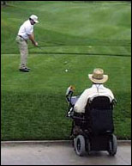
Scan and Select menus, for gamers that are restricted by one or two controls, who can not otherwise access menus independently.

Ability to turn off / adjust negative commentary and sulking gamers animation. It is a little wearing to be groaned at by the crowd and berated by the commentator every time you sink your ball, with no consideration for the disability you might be playing with.

A Course designer with on-line options, would allow courses to be tailor made to suit gamers of different abilities. Real life courses could be replicated leading to the possibility of physically disabled gamers going out onto a real golf course with portable gaming equipment and playing against able-bodied friends in a virtual golf vs. real golf manner. It’s not as far fetched as you may think, with the first such golf tournament having being held in 2000 at Pelican Hill Golf Course in Newport Beach California ^{3.1}. Other applications for this technique include other turn based sports such as darts, snooker and pool^{3.2}.

Ms. Pac-Man (Atari - 1982)

‘Special Feature’
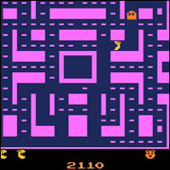
One of a number of golden age^{3.3} Atari 2600 games to feature an inclusive range of difficulty settings. Games with a concession to younger players would be clearly marked with a “Special Feature” bear logo on the box. The biggest names of the time such as Pac-Man, Missile Command, Defender and Berzerk were all marked in this way.

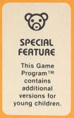
Ms. Pac-Man’s ‘special feature’ was the ability to choose how many ghosts you wished to go up against, from one to four. A simple, but extremely effective way to open the game up to more people.

Suggested Improvements

A Speed control option affecting the entire game.

Destruction Derby (Reflections - 1995)

F355 Ferrari Challenge (Sega – 1999)

The accessibility mechanics designed into these two racing games are of enormous benefit to disabled and younger gamers.

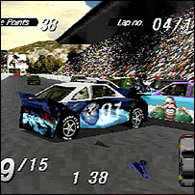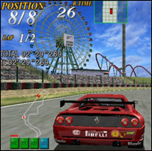

Assist Systems, including I.B.S. (Intelligent Braking System) – F355 Ferrari Challenge

To aid beginners, F355 Challenge has four assist systems that can be toggled at any time whilst driving. These consist of Traction control, Antilock brakes (ABS), Stability Control, and uniquely, an Intelligent Braking System (IBS). This very helpful feature will automatically slow your car down if approaching a corner too quickly. It is therefore possible to race around tracks with just two buttons for left and right, providing you jam the accelerator/gas pedal down.

Steering Assist – Destruction Derby

On ROOKIE level, there is a superb handling feature that automatically corrects your car from a 180° spin. In effect, the game helps you to keep racing in the right direction.

Barriers – Destruction Derby

The barriers in Destruction Derby stretch for the full length of each track without break. These help disabled and younger drivers keep on the road as opposed to being jammed up against scenery or spinning around in ditches. Importantly, the barriers don’t take reduce your speed too much, so you can remain competitive even if grinding your car along them to get around. The benefit of this feature can not be overstated.

Simple Tracks – F355 and Destruction Derby

For learning disabled and physically disabled gamers, the inclusion of very simple tracks can be a boon. This is especially the case for gamers using a single button to play.

Practice Modes – F355 and Destruction Derby

For no pressure racing. If the computer competition is far too hard, there is still a game in beating your own times around the track.

Training mode – F355 Ferrari Challenge

A red line is super imposed on the track showing the racing line to follow, accompanied by visual and spoken prompts of how the road lies ahead. Absolutely fantastic accessibility feature, of benefit to all gamers.

Various – F355 Ferrari Challenge and/or Destruction Derby

Digital Steering and Acceleration; User definable controls; Volume controls (turn off music if distracting); Simple Menu system with clear icons; A commentator that doesn’t’ constantly criticise your driving; A helpful over head scanner giving an idea of how close other cars are to you that would otherwise be in a blind spot.

Some Suggested Improvements

Difficulty Options. F355 is a very hard game to win, and completely impossible for many disabled gamers. The ability to make the game much easier would make the game much more enjoyable.

Toggle on/off option for the accelerator pedal. Holding down this button whilst steering can be uncomfortable, painful or even impossible for some gamers. A toggle option would be the solution.

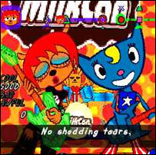

Um Jammer Lammy (Sony – 1999)

A fun rhythm based game, not entirely unlike Dance Dance Revolution in game play. This tough game features a beginner level option that enables you to play by tapping out the correct rhythm using any button. This makes the game far easier for children and players unable to hit the six or so buttons required at the normal level.

This is a great example of a simplified control scheme opening up a game to a larger audience, and could easily be adopted with all rhythm based games.

Emulation (MAME – 1997,2006 and others)

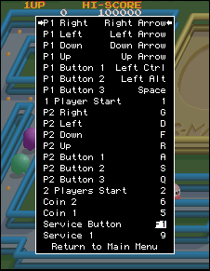
Some disabled people find that they can only access games using software emulators such as MAME (Multiple Arcade Machine Emulator) and MESS (Multiple Emulator Super System). These give the flexibility that just doesn’t exist in most games. Unfortunately they are legally dubious, especially so with the recent shut down of Star ROMs which provided legal games for MAME.

Emulators such as MAME offer many benefits over the original games to disabled gamers:

Fully user-definable controls. Many different controllers and combinations can be assigned to suit the individual gamer. Gamers are also much less likely to find that their favourite controller is incompatible.

Speed controls. Not perfect, nor simple to access, but there is a facility to slow most games down to match each gamers abilities.

Cheats. Or to many disabled gamers, features to make gaming just a little bit easier.

Universally Accessible Games

The previous list touches upon the scattering of accessibility features in games that can aid disabled gamers, which have great value. However, there are some developers looking at making games accessible to all.

UA-Games^{3.4} is such a project, based at the Human Computer Interaction Laboratory (HCI Lab), within the Institute of Computer Science (ICS) in Greece. This organisation is looking into ways that games can be made accessible to all, including multi-player games^{3.5} taking into account the wide range of abilities they may have.

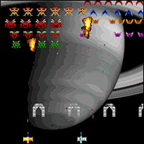
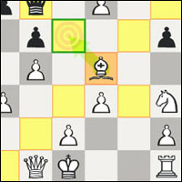

4. One Switch Games

One switch, or ‘one button’ games as they are also known, feature the ultimate in simplified physical controls. One single control is all that is needed to play. With a suitable control interface, movement as fine as a raised eyebrow or as broad as a kicked out leg, can gain access to such games.

For some disabled people, this is the only way into gaming, due to the level of disability. For everyone else, it can be the simplest, and most immediate way to play. What one switch design can do, is bring gamers of absolutely all abilities together to have fun.

There has been increased interest over recent years in one button game play mechanics, for a number of reasons.

One Thumb Mobile Phone Games

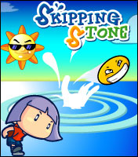
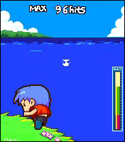
The burgeoning mobile phone gaming market has seen an increase in the number of games designed for single button play, such as Sega’s Sonic Darts and Gamevil’s IGN award winning game Skipping Stone^{4.1}. thanks to their “pick up and play” nature. One button mobile phone games also take into account the wide variety in quality between different mobile phone buttons and joysticks. Gamers who are physically disabled by their phone controls being poorly suited to gaming are able to play on a fairly even footing without having to replace their phone.

© 2005 Gamevil Inc.

Retro Remakes One Switch Competition

PC and on-line one button games have also seen a growth in numbers and popularity. In April of 2005 Retro Remakes^{4.2,} an on-line community of independent game developers ran a competition to create the best strictly one button only game, within a one month time frame. Game menus and all game play had to be accessible via
a single key press. 70 different games were created from this endeavour, some of which used very imaginative approaches to the limitations of a one button interface which shall be discussed later. These games were immediately made available for free download via OneSwitch.org.uk, where take up has been high. This competition has led to coverage across the internet, including the BBC, Guardian and beyond.

GameSutra One Button Game Design

Following this competition GameSutra published an on-line article entitled “One Button Games”^{4.3} by the programmer Berbank Green. This covered the wide variety of functions a single button can have, in a very clear and comprehensive manner. It is a good starting point for programmers interested in this aspect of accessible game design.

Brand New, You’re Retro

Despite this recent activity in one button game design, it is worth noting that such games are certainly not a new phenomena. Atari released Canyon Bomber around 1977 into Video Arcades, and in 1979 on the Atari VCS games console. The following quote from programmer Howard Delman^{4.4} explains his game:

“Canyon Bomber was a two player competitive game. Players controlled two vintage aircraft... a bi-plane and a blimp. The aircraft flew back and forth over a canyon filled with numbered targets. The player had only one control - a button marked "drop". His objective was to time the release of his bombs so as to hit the most targets. He played continuously, until he used up his allotment of misses. As the targets were destroyed, and the canyon got emptied, the competition really heated up”.

A more recent one switch coin-operated machine is Cave’s Uo Poko, released in Asian arcades around 1998. This game takes cues from Taito’s Puzzle Bobble, whereby the aim is also to burst balls by getting three or more of the same colour to touch. It differs in several ways, most prominently in its control mechanism which requires only a downward pull on a digital joystick. This in turn pulls on a spring, which fires out quasi-random colours of balls, in a similar style to many PC pinball games. The longer you hold down your control, the more powerfully the ball is fired onto the playing field. Uo Poko features a superb co-operative two player mode, that has the potential to have people of massively different abilities playing together.

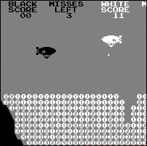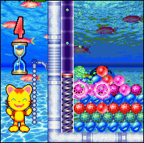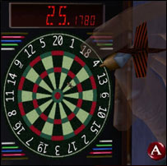

images from left to right: Canyon Bomber (Atari 1977); Uo Poko (Cave 1998); Shenmue (Sega 1999,2000)

Console single switch games

Aside from these, fairly obscure arcade games, you can find one button games appearing in a number of better known console games. Sony’s Um Jammer Lammy for the Playstation featured a single button ‘easy’ mode as mentioned above. Nintendo’s Wario Ware Inc. for the Game Boy Advance featured many different styles that including button mashing games in the vein of Konami’s Track & Field and plain daft games such as timing a constantly moving hand to pick a nose! Sega’s epic Role Playing Game Shenmue featured a mini-game of darts that proved to be an addictive diversion in itself. Here a constantly wandering hand roams the dartboard, waiting for the player to press a single button in order to throw one of five darts.

However, these arcade and console games are not true one button games. They typically require other controls to navigate menus before you can get to the stage of playing. They therefore preclude some disabled gamers from playing independently. At the end of each game, they might require the assistance of another person to restart the game, proving to be a frustration.

True One Switch Games

The games written for the Retro Remakes competition feature scan and select menus that make the entire game accessible using a single button or switch. The following are some notable examples, that are all available free from www.OneSwitch.org.uk.

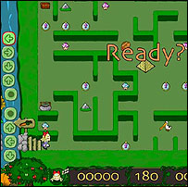

Alice Amazed (Tesa & Michi - 2005) ^{4.5}

A highly polished game, with a plot, recognisable characters, variety and some absolutely superb accessibility features.

- Wide range of difficulty levels from Very Easy to Very Hard
- A Scan and select menu and game play elements, with speed adjustment
- Mini-games are available from the menu to play individually.
- Two player option. If a gamer is being continuously beaten by the computer, two player options give them the possibility at winning (whether fairly or not) against a human, who may be more of an even match.

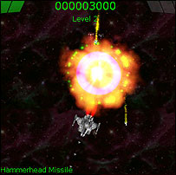
Aurikon (Aggressive Game Designs - 2005) ^{4.6}

An on-rails 2D shoot-em-up that could work equally well in 3D. A well-paced game with strategic elements, and some imaginative ideas.

- Speed adjustment option affecting the entire game.
- Wide range of difficulty level adjustment.
- Control sensitivity adjustment. The button used has two states: Tapping fires a missile & Holding activates thrust. Some disabled gamers can not press a button quickly, so this adjustment can make the difference between a playable game or unplayable game.
- Branching options and rotating weaponry stash add a strategic element.

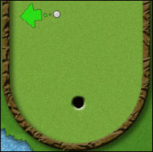

Mini Golf One Button Style (Danny Boyd – 2005) ^{4.7}

Featuring an aiming system that could be adopted for use with 3D golf games. An arrow constantly rotates around your ball. When you press your button the arrow locks into the direction that you will strike the ball. The game then moves to a power bar that constantly adjusts. You simply need to time your press to get the right amount of power.

- No hook or slice.
- Practice modes.
- Simple targeting and shot power selection method.
- No time limit on taking a shot. You can take all the time you need.

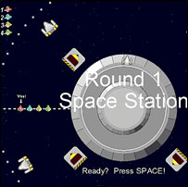

Orbit Racer (Pug Fugly Games – 2005) ^{4.8}

A space race game in the vein of Atari’s Super Sprint. Your ship is constantly veering to the right, which thanks to the circular nature of the tracks, will keep you heading in the right direction. Pressing your button simply steers you in the opposite direction, where you can aim to collect power-ups.

- Simple round tracks enable one button play.
- Barriers do not slow your craft down too much.

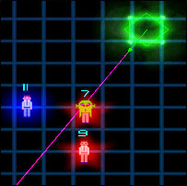

Sentinella (Leonardo Sala – 2005) ^{4.9}

Takes elements from the 2 joystick (16 switch) classic Robotron: 2084, one button mechanics and comes up with a very tense, strategic arcade game.

- Adjustable difficulty level.
- Well gauged learning curve.
- Superb ideas.

Can All Games Be Turned Into One Switch Games?

With enough willing, pretty much any game could be made playable using a single switch or button. Gaming aids would be necessary for many games, such as automatic aiming and branching scan and select options where you can choose certain paths. This would be a considerable challenge for many programmers. However this doesn’t mean that single switch games need to stay the preserve of simple arcade type games. This is most ably demonstrated by Ominous Development’s Strange Attractors.

5. Strange Attractors one switch game by Eric Walker

Strange Attractors (www.ominousdev.com)

Strange Attractors^{5.1} is a one switch game where you control forces of gravity to play. You can sling-shot your-self around artificial planets, and bounce off obstacles following slightly bent laws of physics. It’s an incredible game that takes some getting used to. This game was a finalist in the Independent Game Festival 2006, for innovation in game-play.

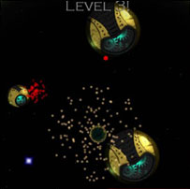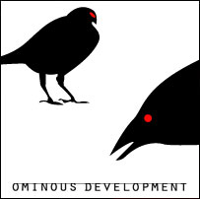

6. Accessibility Tips For Any Game

The following advice is not a prescription for creating games that will be accessible to all. However, if designers choose to implement just one of these accessibility tips, it can make a huge difference. Possibly, the difference between a playable game, and an unplayable game.

• Consider simplifying menus

Can a game be started easily and quickly? Can the menus be navigated using a small number of controls? Some games require seven or more different buttons to adjust options. This is not helpful for many gamers. Consider using clear icons to back up text, and a quick start method. Ideally, consider scan and select methods to take into account gamers using a very small number of controls.

• Allow all controls to be remapped

Many people can benefit from tailoring all controls to suit themselves. This is especially beneficial when realising the great diversity of controllers that people may be using. It is also very useful to include the facility to duplicate actions onto two or more controls. For instance a person may find firing continually with the same finger tiring, so to have an alternative control that can do the same can be helpful. MAME is an excellent present day example of how a diverse range of controllers can be rendered accessible.

• Provide a simplified control method

Think about your game, and if an alternative playing method could be used to reduce the number of controls. Consider that some people can only play using digital controllers, with fewer buttons. Could your game be adapted to be playable with a single joystick and a few buttons? Could you reduce these controls further, to take into account an even greater range of disabled gamers? Could your game be made playable with a single button, even if only in an alternative mini-game form?

• Consider gamers unable to hold down buttons for lengthy periods

Some gamers find holding down buttons for prolonged periods a painful experience. These include people with Arthritis and people using one handed controllers. A simple ‘toggle button on/off’ option would help solve this issue, where one press of the button locks the action on, and another press turns it off.

• Provide a difficulty option that spans a very broad range

This is extremely important, and frequently overlooked. Perhaps some game developers are concerned that if they include an option making their game ‘too easy’ it will serve as a game spoiler. Being frustrated and disabled by a game that is too hard must be the greatest game spoiler of all. The broader the range offered, the more inclusive the game becomes. There is no such thing as too easy.

• Offer speed options

Where people’s reactions are slower than average, due to ageing for example, being able to reduce the speed of a game can help massively with playability. Again, there is no such thing as too slow.

• Provide gamer assist aids

The inclusion of training options can give players the chance to play at their own pace, with much less pressure. This can offer fun and respite for players frustrated by the main game. Other assist modes might include automatic targeting, invincibility and ghost town modes where you would be free to explore the game world unimpeded.

• Use the One Switch standard for one button games

For consoles, allow all controls to be user-defined and interchangeable. Allow for multiple button assignments for the same action. Bear in mind that all controls may need to be digital.

For PC and Macintosh computers, The SPACE BAR and LEFT MOUSE button should both function as the default player one control. The default PLAYER TWO control should be operated via The RETURN key and RIGHT MOUSE button. The ESCAPE key should function as a way to QUIT. Again, allow users to user-define their controls if they wish to break from this standard. All this should ensure compatibility with vast majority of switch interfaces.

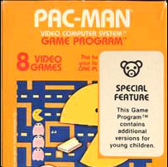
• Announce accessibility features on packaging

A standard needs to be agreed for categorising and announcing accessibility features, along the lines of the American ESRB^{6.1} and European PEGI^{6.2} age ratings systems. This will make life easier for game producers and consumers alike. This is an area that the IGDA’s Special Interest Group in Game Accessibility is presently looking into.

In temporary lieu of an accessibility ratings system, any mention of accessibility features on packaging would be a good start. As previously mentioned, this was something that Atari did at the peak of it’s popularity, and would be simple to replicate.

• Consider Universal Access

The ultimate goal. Games that include the greatest numbers of people possible.

7. Conclusion

There is a huge potential market of disabled, young, and novice gamers being excluded by the inaccessible nature of most main-stream games. It should also be pointed out that anyone in the world can become disabled at any time, through accident, illness or through the natural effects of ageing.

Many accessibility features are fairly easy to implement during game development, such as wide difficulty level and speed control options. More involved features such as highly accessible menus could be formed from open source or leased templates, saving developers much time. Nothing is impossible.

We hope there will be a change in the future.

Barrie Ellis
OneSwitch.org.uk and IGDA Special Interest Group on Game Accessibility

Barrie Ellis has been building accessible controllers for disabled people since 1995 and has an NVQ level 3 in Promoting Independence. He presently works part-time on www.OneSwitch.org.uk which concentrates on promoting fun activities that severely learning and/or physically disabled people can enjoy. He lives in Billericay, Essex in England with his partner, 8-year old daughter and heaving loft full of unusual controllers and games consoles.

e-mail: barrie.ellis@oneswitch.org.uk
web-site: www.oneswitch.org.uk

Footnotes

1.1 “In 1971 Nolan Bushnell and Ted Dabney created a coin-operated arcade version of Spacewar and called it Computer Space. Nutting Associates bought the game, hired Bushnell, and manufactured 1,500 Computer Space machines. The game was not a success because many people found it difficult to play.” - Source: Wikipedia “History of computer and video games”

1.2 Defender © Williams Electronics 1980, uses five buttons and a 2-way joystick for game play.

2.1 Nintendo’s Hands Free controller, designed by Lance Barr, was released in 1988 for the Nintendo Entertainment System – Source: http://www.oneswitch.org.uk/2/pioneers.htm

3.1 “Using … assistive computer technology from Madentec, people with quadriplegia golfed right beside their able-bodied counterparts on an actual course using a wheelchair-mounted computer running Microsoft's Links LS 2000 golf software. A replica of the Pelican Hill golf course was stored in the computer software down to every detail. People with disabilities golfed virtually, using the computer software and assistive technology. These people participated on the same teams as the able-bodied golfers. The golfers with disabilities drove from hole to hole on the real course in their powered wheelchair, following the shots they are making on the computer mounted in front of them. The other golfers will ride in slightly less style in powered golf carts”. – Source: - http://www.at508.com/abletv/event_real_abilities.asp

3.2 “Computer versions of real-life games, such as darts, pool, bowling & roulette can be set up alongside the real thing, enabling people of all abilities to compete on the same game. Take this system with you to social clubs, snooker halls, pubs & casinos! – Source: http://www.oneswitch.org.uk/2/I/Playstation-PC/Iplaystation15.htm

  - The Golden Age of Gaming can be considered to be between the release of Taito’s Space Invaders in 1978 and the ‘great video gaming crash’ of 1983 – Source: http://en.wikipedia.org/wiki/Video_game_crash_of_1983

  - UA-Games - www.ics.forth.gr/hci/index.html

  - The Theory of Parallel Game Universes: A Paradigm Shift in Multiplayer Gaming and Game Accessibility
- http://www.gamasutra.com/features/20060817/grammenos_01.shtml

4.1 IGN ‘Wireless Game of the Year 2005’ - Source: http://bestof.ign.com/2005/wireless/15.html

4.2 Retro Remakes provides help and support for independent programmers interested in creating new retro themed games. They have been instrumental in bringing a huge number of new single switch accessible games into existence. - Link: http://www.retroremakes.com

4.3 Game Sutra ‘One Button Games’ design - Link: http://www.gamasutra.com/features/20050602/green_01.shtml

4.4 Canyon Bomber, Atari Inc. 1977 - Link: http://www.rawbw.com/~delman/canyonb.html

  - Alice Amazed (Michi & Tesa) - Link: http://www.michi.nu/alice
4.6 Aurikon (Aggressive Game Designs) - Download: http://www.idiombox.com/oneswitch/Aurikon.exe

4.7 Mini Golf One Button Style (Danny Boyd) - Link: http://www.acsv.net/acsite/viewsoftware.php?id=120
4.8 Orbit Racers (Pug Fugly Games) - Link: http://www.pugfuglygames.com/orbit_racers.html
  - Sentinella (Leonardo Sala) - Download: http://www.idiombox.com/oneswitch/Sentinella.zip

5.1 Strange Attractors – Link: http://www.ominousdev.com/

6.1 Entertainment Software Rating Board (ESRB) age ratings - Link: http://www.esrb.org/esrbratings.asp

6.2 Pan European Game Information (PEGI) ratings system - Link: http://www.pegi.info/

Some Useful Contacts

Game-Accessibility.com
http://www.game-accessibility.com/
e-mail: gaforum@accessibility.nl

IGDA Game Accessibility Special Interest Group
http://www.igda.org/accessibility
e-mail: accessibility@igda.org

OneSwitch.org.uk
http://www.oneswitch.org.uk
e-mail: barrie.ellis@oneswitch.org.uk

Retro Remakes – Accessibility Angle Forum
http://www.retroremakes.com/forum2/forumdisplay.php?f=84

Interaction Design Pattern Library for Games
http://www.eelke.com/research/accessibility.html

